Dear Parent or Guardian,
This autumn the school has chosen to support the Christmas box appeal run by FSCI (www.fscinet.org). We are asking for donations of items in bulk (e.g. a dozen toothbrushes) from families. Once the items are collected into the school the pupils will make up presents for children and families in Southeast Europe. This is a very cost effective way of making up lots of Christmas boxes!

Please also consider donating £3 to help FSCI cover the cost of shipping our boxes to Southeast Europe.
Plus we need empty shoeboxes!

List of items needed for Christmas boxes (feel free to donate more than one type of item should you wish!).
- Sweets
- Toys (vehicles/dolls etc)
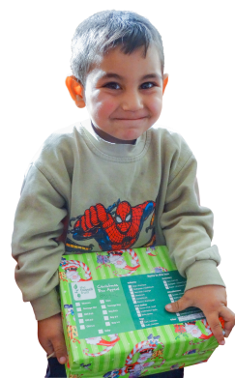
- Hats/gloves
- Balls (tennis, bouncy)
- Small “loom” kits

Deadline to get items &
donations into school:
Weds 31st Oct 2018

FSCI (UK) Reg. Charity in England & Wales No. 1170914

Dear Parent or Guardian,
This autumn the school has chosen to support the Christmas box appeal run by FSCI (www.fscinet.org). We are asking for donations of items in bulk (e.g. a dozen toothbrushes) from families. Once the items are collected into the school the pupils will make up presents for children and families in Southeast Europe. This is a very cost effective way of making up lots of Christmas boxes!

Please also consider donating £3 to help FSCI cover the cost of shipping our boxes to Southeast Europe.
Plus we need empty shoeboxes!

List of items needed for Christmas boxes (feel free to donate more than one type of item should you wish!).
- Soap
- Toothpaste, brushes
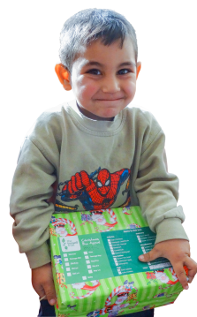
- Small toys, balls
- Facecloths
- Hair accessories

Deadline to get items &
donations into school:
Weds 31st Oct 2018

FSCI (UK) Reg. Charity in England & Wales No. 1170914

Dear Parent or Guardian,
This autumn the school has chosen to support the Christmas box appeal run by FSCI (www.fscinet.org). We are asking for donations of items in bulk (e.g. a dozen toothbrushes) from families. Once the items are collected into the school the pupils will make up presents for children and families in Southeast Europe. This is a very cost effective way of making up lots of Christmas boxes!

Please also consider donating £3 to help FSCI cover the cost of shipping our boxes to Southeast Europe.
Plus we need empty shoeboxes!

List of items needed for Christmas boxes (feel free to donate more than one type of item should you wish!).
- Gloves/hats/scarves
- Pens/pencils/cases
- Small toys
- Toothpaste, brushes
- Combs

Deadline to get items &
donations into school:
Weds 31st Oct 2018

FSCI (UK) Reg. Charity in England & Wales No. 1170914

Dear Parent or Guardian,
This autumn the school has chosen to support the Christmas box appeal run by FSCI (www.fscinet.org). We are asking for donations of items in bulk (e.g. a dozen toothbrushes) from families. Once the items are collected into the school the pupils will make up presents for children and families in Southeast Europe. This is a very cost effective way of making up lots of Christmas boxes!

Please also consider donating £3 to help FSCI cover the cost of shipping our boxes to Southeast Europe.
Plus we need empty shoeboxes!

List of items needed for Christmas boxes (feel free to donate more than one type of item should you wish!).
- Pens/pencils/cases
- Colouring/sticker books
- Jigsaws/small “loom” kits
- Sweets
- Hair accessories

Deadline to get items &
donations into school:
Weds 31st Oct 2018

FSCI (UK) Reg. Charity in England & Wales No. 1170914

