Dear Friends,
This autumn the/our church/business/community group has chosen to support the Christmas box appeal run by FSCI (www.fscinet.org). We are asking for donations of items in bulk (e.g. a dozen toothbrushes) from you. Once the items are collected into us here we will make up presents for children and families in Southeast Europe. This is a very cost effective way of making up lots of Christmas boxes!

Please also consider donating £3 to help FSCI cover the cost of shipping our boxes to Southeast Europe.
Plus we need empty shoeboxes!

List of items needed for Christmas boxes (feel free to donate more than one type of item should you wish!).
- Sweets
- Toys (vehicles/dolls etc)
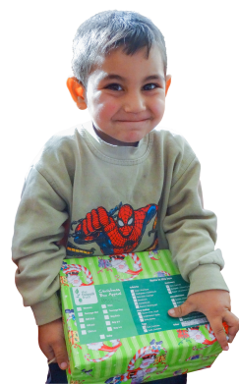
- Hats/gloves
- Balls (tennis, bouncy)
- Small “loom” kits

Deadline to get items &
donations in by:
Thurs 31st Oct 2019

FSCI (UK) Reg. Charity in England & Wales No. 1170914

Dear Friends,
This autumn the/our church/business/community group has chosen to support the Christmas box appeal run by FSCI (www.fscinet.org). We are asking for donations of items in bulk (e.g. a dozen toothbrushes) from you. Once the items are collected into us here we will make up presents for children and families in Southeast Europe. This is a very cost effective way of making up lots of Christmas boxes!

Please also consider donating £3 to help FSCI cover the cost of shipping our boxes to Southeast Europe.
Plus we need empty shoeboxes!

List of items needed for Christmas boxes (feel free to donate more than one type of item should you wish!).
- Soap
- Toothpaste, brushes
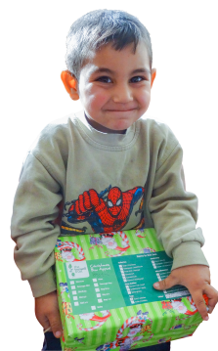
- Small toys, balls
- Facecloths
- Hair accessories

Deadline to get items &
donations in by:
Thurs 31st Oct 2019

FSCI (UK) Reg. Charity in England & Wales No. 1170914

Dear Friends,
This autumn the/our church/business/community group has chosen to support the Christmas box appeal run by FSCI (www.fscinet.org). We are asking for donations of items in bulk (e.g. a dozen toothbrushes) from you. Once the items are collected into us here we will make up presents for children and families in Southeast Europe. This is a very cost effective way of making up lots of Christmas boxes!

Please also consider donating £3 to help FSCI cover the cost of shipping our boxes to Southeast Europe.
Plus we need empty shoeboxes!

List of items needed for Christmas boxes (feel free to donate more than one type of item should you wish!).
- Gloves/hats/scarves
- Pens/pencils/cases
- Small toys
- Toothpaste, brushes
- Combs

Deadline to get items &
donations in by:
Thurs 31st Oct 2019
FSCI (UK) Reg. Charity in England & Wales No. 1170914

Dear Friends,
This autumn the/our church/business/community group has chosen to support the Christmas box appeal run by FSCI (www.fscinet.org). We are asking for donations of items in bulk (e.g. a dozen toothbrushes) from you. Once the items are collected into us here we will make up presents for children and families in Southeast Europe. This is a very cost effective way of making up lots of Christmas boxes!

Please also consider donating £3 to help FSCI cover the cost of shipping our boxes to Southeast Europe.
Plus we need empty shoeboxes!

List of items needed for Christmas boxes (feel free to donate more than one type of item should you wish!).
- Pens/pencils/cases
- Colouring/sticker books
- Jigsaws/small “loom” kits
- Sweets
- Hair accessories

Deadline to get items &
donations in by:
Thurs 31st Oct 2019

FSCI (UK) Reg. Charity in England & Wales No. 1170914

